# HR Analytics Dashboard

By Biswanandan Hota

**Overview**

The **HR Analytics Dashboard** provides a comprehensive overview of key human resource metrics to help monitor workforce composition, attrition, satisfaction, and performance across the organization. It consolidates multiple insights into a single view for strategic decision-making.

**Dashboard Sections**

**1️⃣ Key Performance Indicators (KPIs)**

* **Attrition Count:** Number of employees who have left the organization (terminated).
* **Attrition Rate:** Percentage of employees who left relative to the total workforce.
* **Active Employees:** Number of currently employed staff.
* 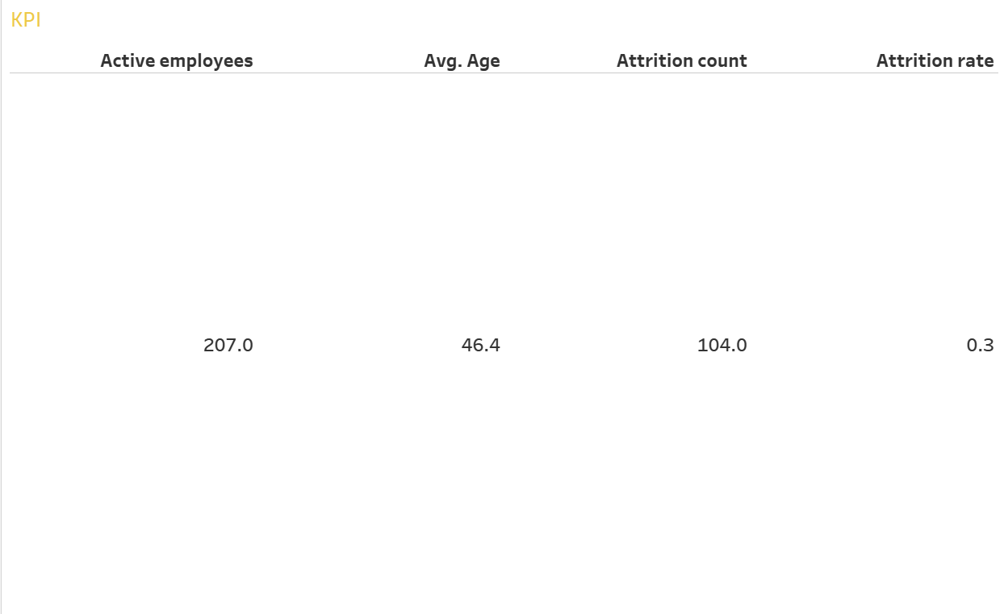**Average Age:** Average age of employees, derived from date of birth.

**2️⃣ Attrition Analysis**

* 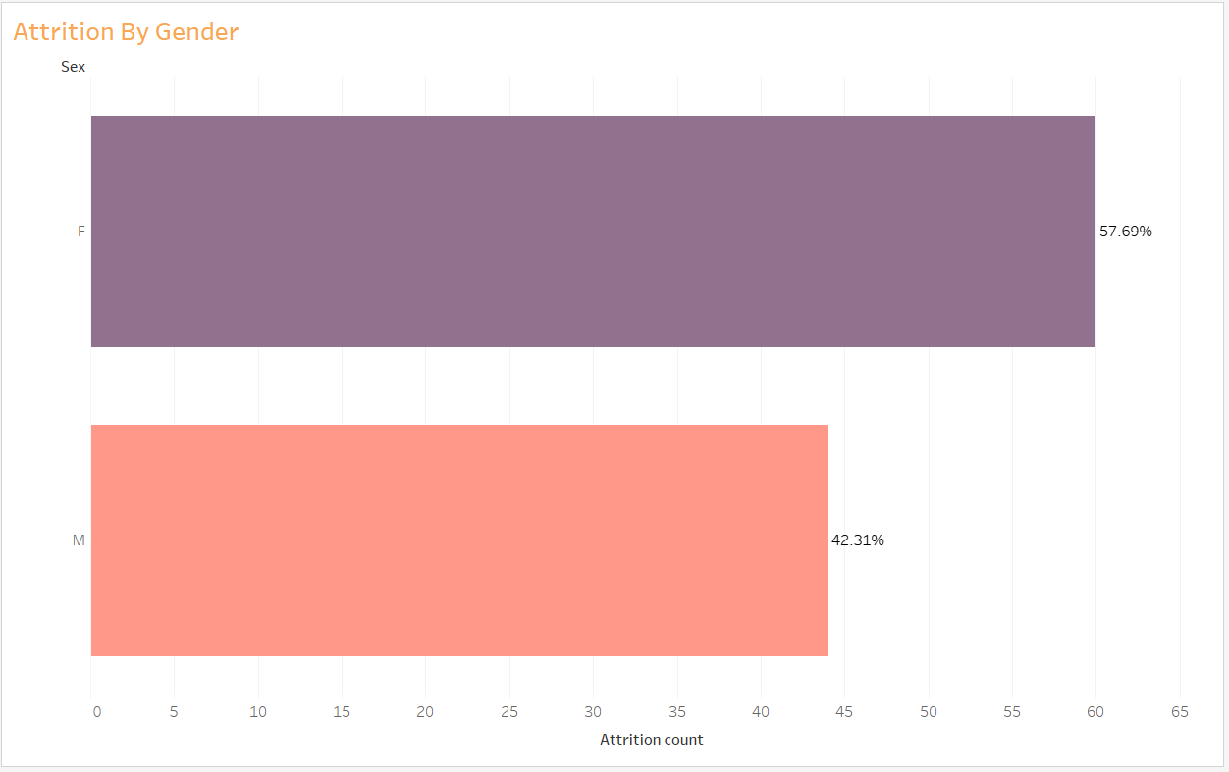**Attrition by Gender:** A bar chart showing the number of employees who left, segmented by gender, to identify diversity impacts.

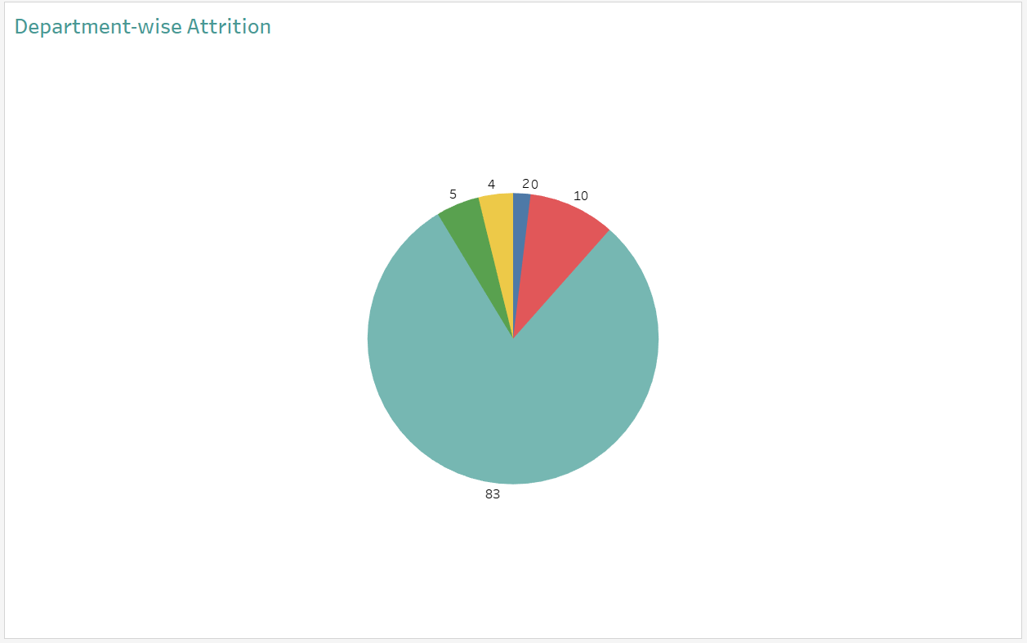**Department-wise Attrition:** Visualization showing attrition counts by department, helping pinpoint areas with high turnover.

**Education Field-wise Attrition:** Replaced by analysis using Position or Department due to data limitations, showing how attrition varies across functional areas.

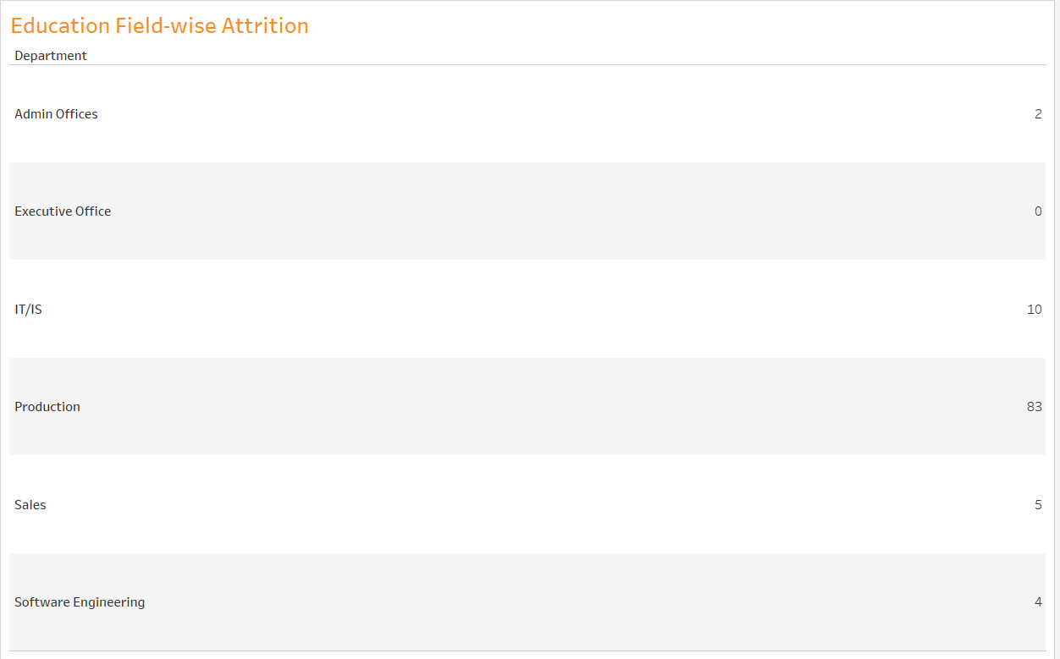

**3️⃣ Demographics & Workforce Composition**

* **Number of Employees by Age Group:** Distribution of employees across defined age bins (<25, 25–34, 35–44, 45–54, 55+), identifying generational composition.

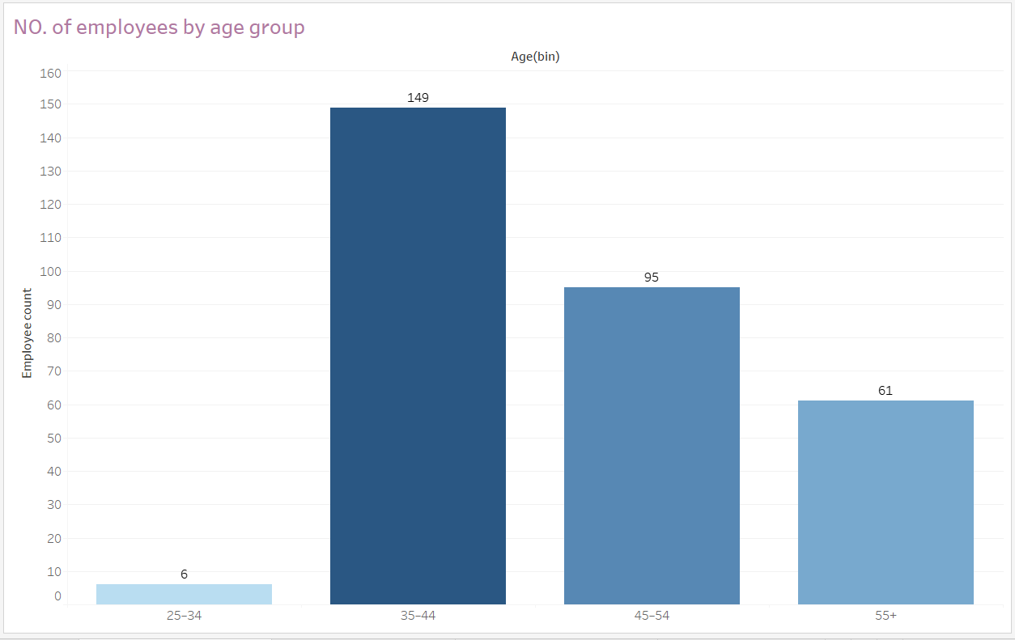

**Attrition Rate by Gender and Age Group:** A dot or heatmap-style visualization showing how attrition varies across different gender and age segments.

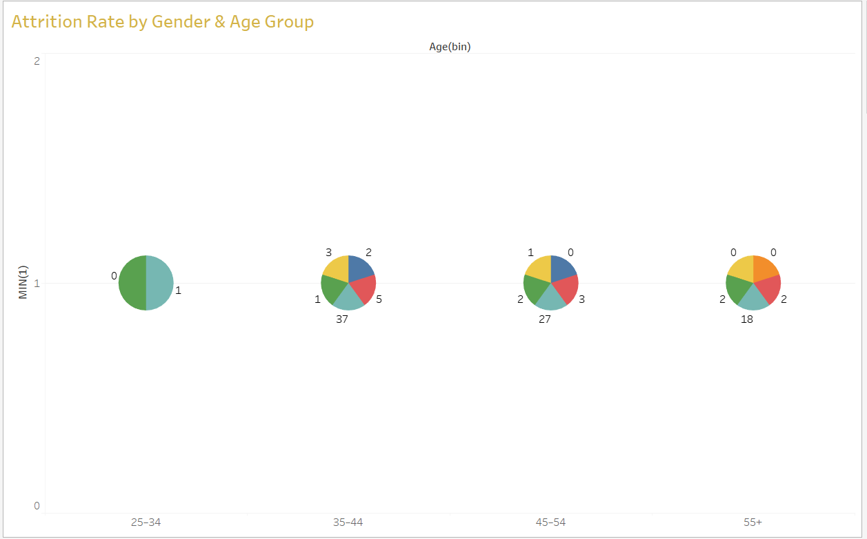

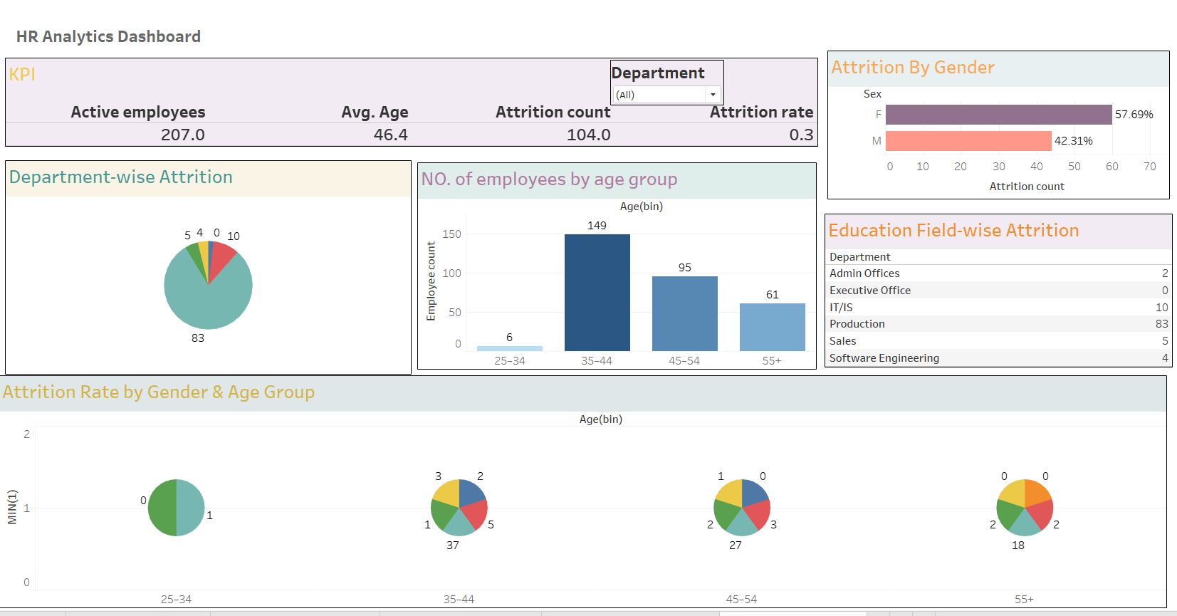**Dashboard**

**Data Notes**

* Age and Age Bin were calculated directly from employee DOB.
* Attrition is defined by the Term field (1 = terminated).
* Education data was not available; Position or Department fields were used instead.
* MIN(1) technique used for certain visual layouts without a natural measure.
* % of Total applied as a quick table calculation in charts to contextualize proportions.

**Strategic Value**

This dashboard allows HR leaders and management to:  
✅ Track workforce trends and demographics  
✅ Identify departments with higher attrition risk  
✅ Understand engagement levels across roles  
✅ Support diversity and inclusion analysis  
✅ Drive data-backed retention strategies